Steps to Remove Account (IOS)
- Step 1: Go to Settings > Mail, Contacts, Calendars. The Accounts screen will open.
- Step 2: On the Accounts screen, tap the Exchange Account you want to remove.
- Step 3: Scroll down and click Delete Account. A Delete Account warning window will open.
- Step 4: On the Delete Account warning window, click Delete Account to finish. You have successfully deleted your Exchange account.
Steps To Add Exchange Account (IOS
Tap Settings > Mail, Contacts, Calendars > Add Account > Exchange.
Enter your information
Enter your email address and password. If you want to, you can also enter an account description.
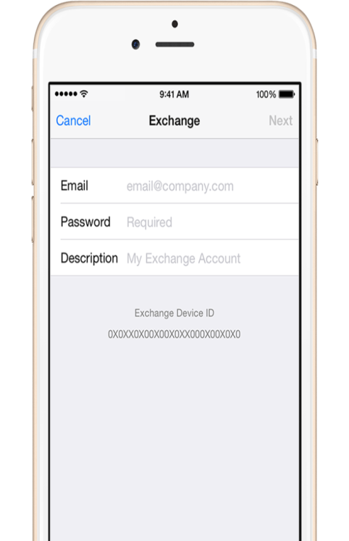

Connect to the Exchange Server
Your iOS device will try to find your Exchange Server. You might have to enter additional server information. Our server name is mailserver.medinah11.org. Your username is the one you normally use to login with. You don’t need to enter domain
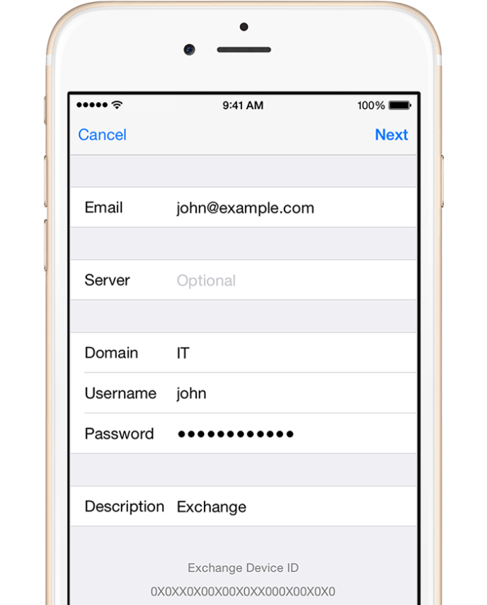

Sync your content
You can sync Mail, Contacts, Calendars, Reminders, and Notes. When you're finished, tap Save.
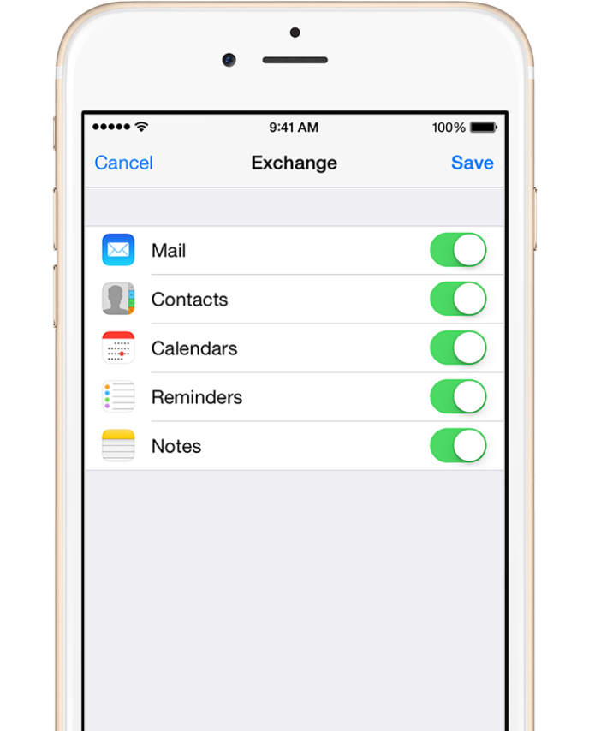

Edit your Exchange settings
Tap Settings > Mail, Contacts, Calendars, select your Exchange account, and tap Account Info. You can also go here to set up automatic out-of-office replies and change how often you want Mail to sync (the default is 7 days).

